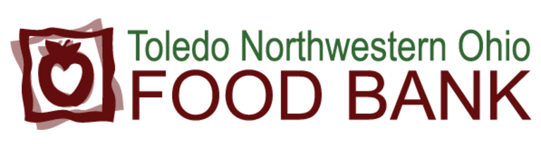

As evidence of my desire to aid future generations, and assure the ability of the Toledo Northwestern Ohio Food Bank (TNOFB) to continue its mission to end hunger in Toledo and Northwest Ohio, I hereby inform the TNOFB that I have made provision for a legacy gift to the TNOFB in my estate plan. I am interested in providing this legacy because:
________________________________________________________________________________________________________________________________________________________________________________________________________________________________________________________________________________________________________________________________________________________________________

It is my intent to leave this legacy to the TNOFB though my:
- Will
- Living Trust
- Retirement Plan Assets
- Charitable Remainder Trust
- Life Insurance Policy
- Other ___________________________

I wish to inform the TNOFB, for long-term planning purposes only, that as of this date, the value of my gift is $_____________. (If your gift is a percentage of your estate, please indicate the approximate present value of that percentage.) I understand that, by completing this letter of intent and stating an amount, my estate is not legally bound by this statement and I may choose to add to, subtract from, or revoke this bequest at any time.

It is my desire that my bequest be used to ________________________
__________________________________________________________
__________________________________________________________, which purpose is and shall be consistent with the TNOFB policies and with its status as a tax-exempt organization. I am making this gift
- In honor of________________________________.
- In memory of_______________________________.

I understand an agree that, should it ever become impossible or impractical to use the gift for the purpose specified in this agreement that the Board of Directors and the President & CEO of the TNOFB in their discretion, may use my bequest in support of any other uses most similar to my original interest and intent.

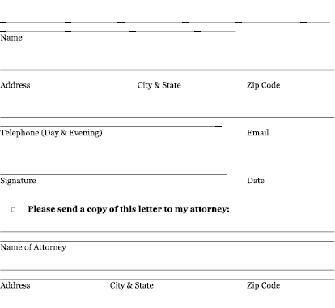

- To encourage others to participate, I give permission for the Toledo Northwestern Ohio Food Bank to list my name in its legacy society or publications.

_______________________________________________________________
(Please print your name as you wish to appear)

